Ronnie Yuan

CS 370 Project

**Accuweather User Manual**

1. How to compile and run Accuweather System:

Open Command Line:

* 1. Set Path to flash drive
  2. To Compile, type: javac UI.java
  3. To Run, type: java UI backUpData.txt

1. After following step 1, a login window will appear. This will allow us to either log in as a user or administrators. Users have the limited ability to search for the weather forecast by region as well as using the offline query option to view information about existing items in the hash table. Administrators can do all Users can do & more! They have the power to add, modify, delete weather forecast information, view the transaction log and backing up all data stored.

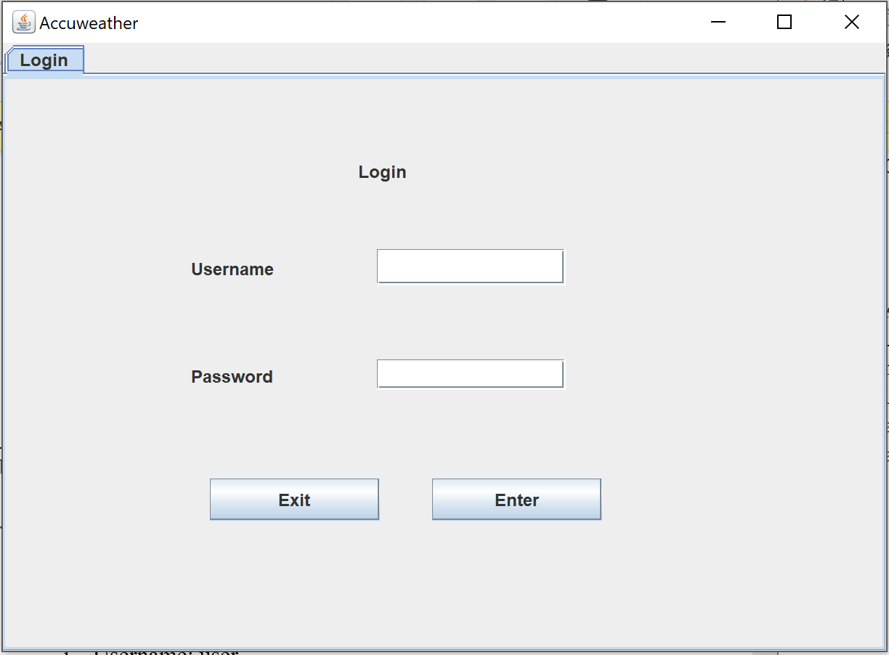

The username field and the password field must both filled be in. The login button must then be pressed.

* 1. To log in as an administrator:
     1. Username: administrator
     2. Password: 1111
  2. To log in as a user:
     1. Username: user
     2. Password: 0000

In this example, we will log in as an administrator. We type in "administrator" in the username field and "1111" in the password field. We then press the Enter button.

1. After successfully logging in as an administrator, five more tabs will be displayed. They consist of Search, Offline, Add/Edit, Delete, System, and Login.

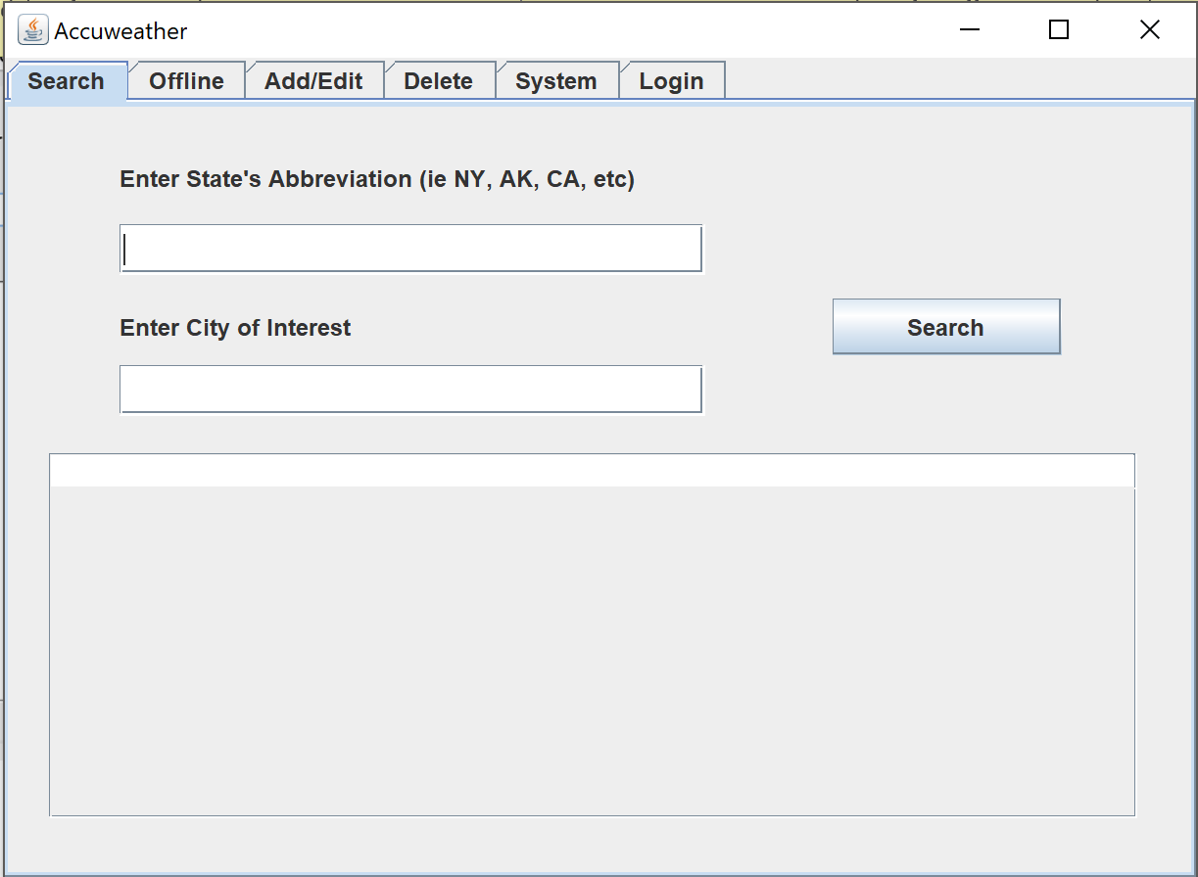

1. The first tab, Search, is the only one of the five that requires an internet connection.

It allows for the user to search for information about the current weather forecast in their desired region. In order to do this, the User needs to input the abbreviation of their State of interest (ie. ny, ak, ca, ma, etc) as well as the City. The search result will display the zip code and unique location key associated with the user’s input. This followed by information about the current forecast in that region. The Temperature, Real Feel, and Weather Conditions will be projected.

All of the data in the search result will be stored into the hash table by the system. In order for users/ administrators to view the information of a particular search result, they have to go to the offline tab.

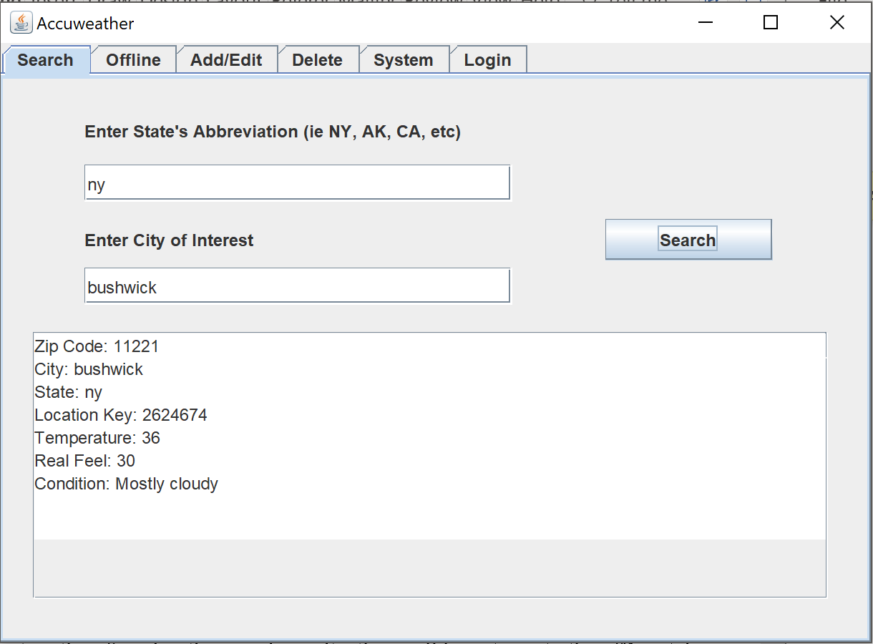

1. In the Offline tab, you can obtain information about existing weather forecast info in the hash table whether they were stored from searches or manually added by administrators. As a result of this, an internet connection isn't required as it was in the Search tab.

When making an offline query to obtain more information about the weather in a region, the zip code must be entered. In this example, the weather forecast of forest hills has already been stored in the database.

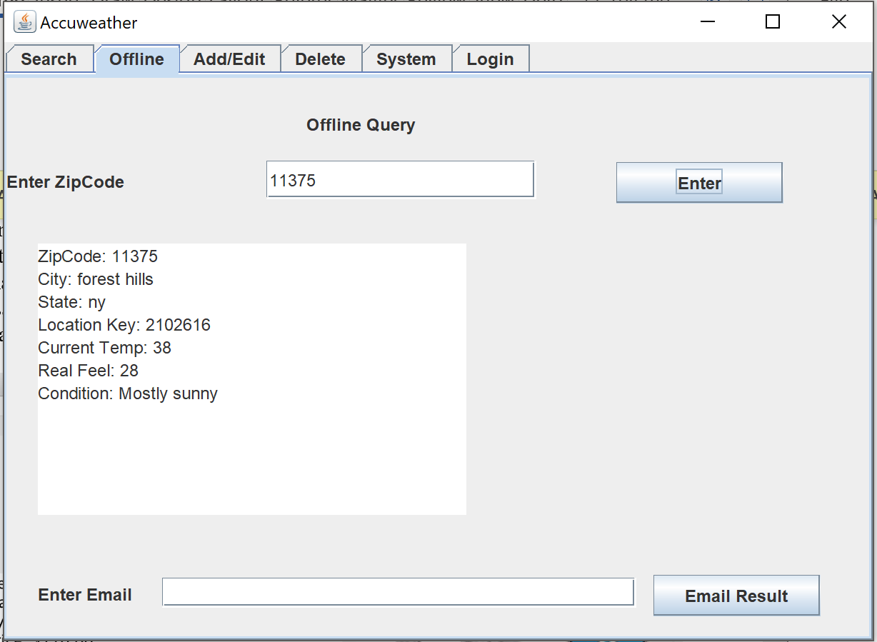

1. In the add/edit tab, administrators can insert weather forecast information into the hash table and be able to modify the ones that already exist.

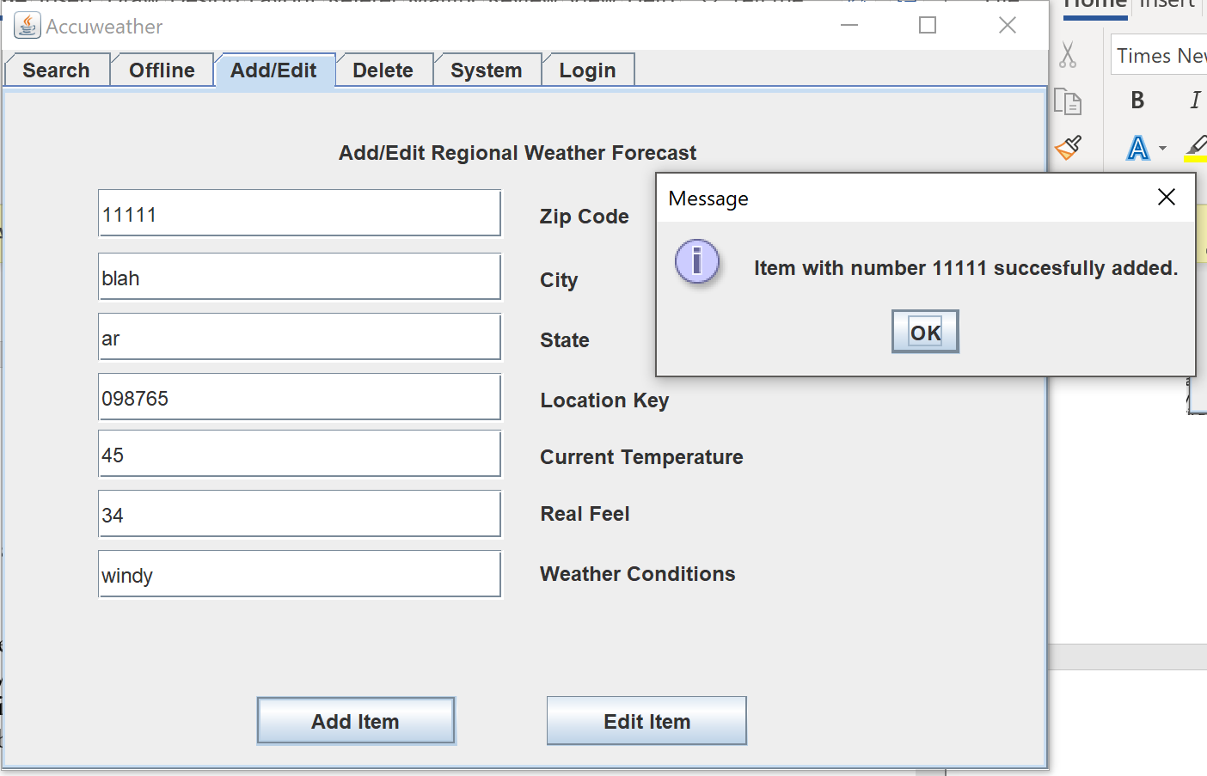

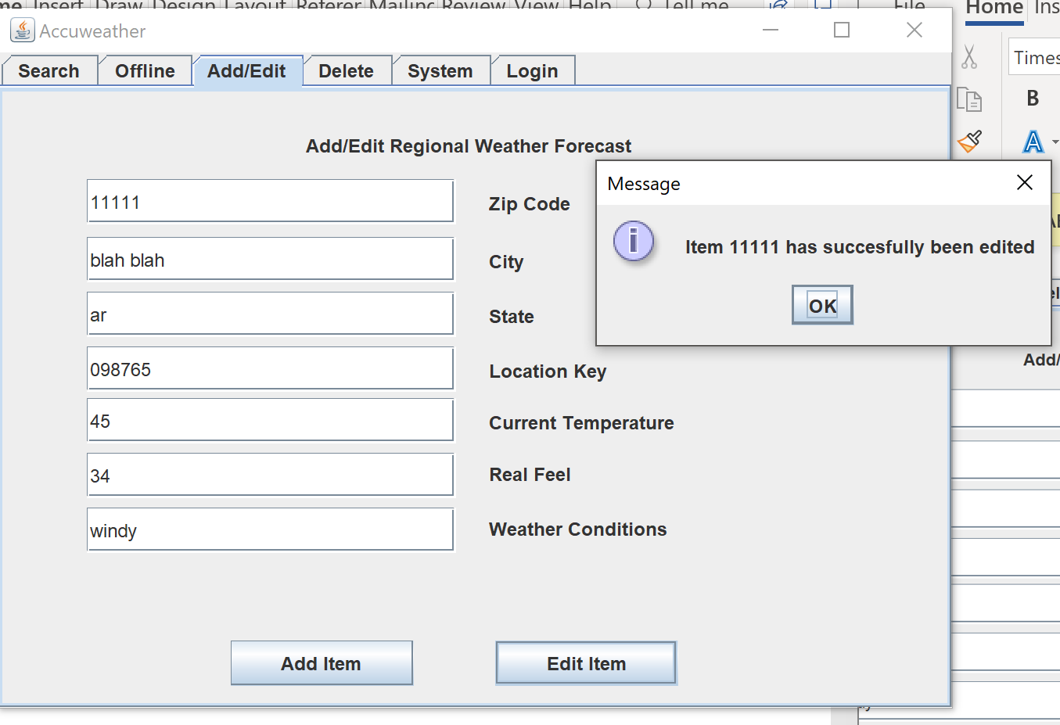

1. In the delete tab, administrators can delete weather forecast information into the hash table by zip code.

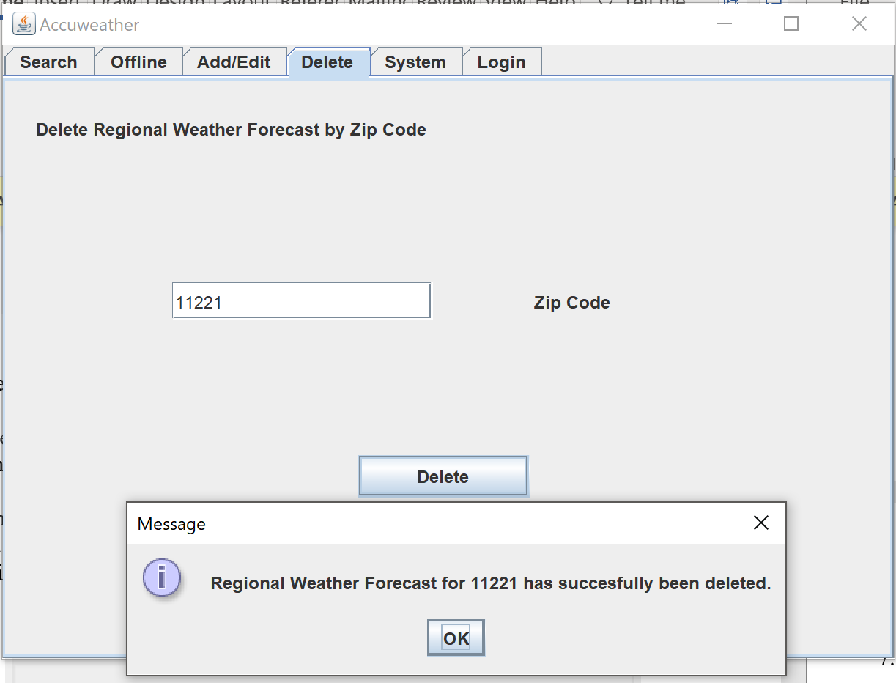

1. Under the System Tab, administrators have different options for viewing data.

